Practice worksheet set 02
Q1 Identify by putting a tick mark whether the following represents a function or not. [3] 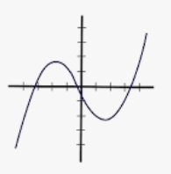 | (b)  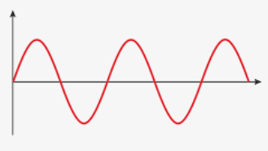
Yes | No | Yes | No

Q2 Determine the domain and range of the following functions
(a)  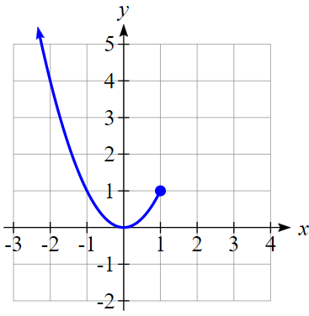 | (b)  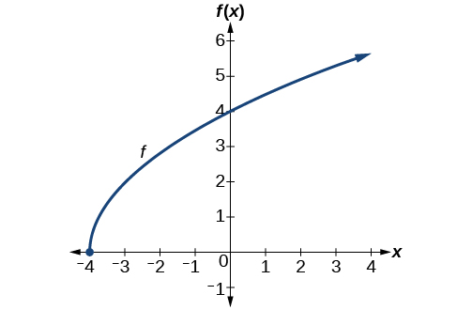
3. State the natural domain of the following functions [2]
- $f\left(x\right)= \sqrt{6-x}$ (b) $f\left(x\right)=\frac{3x}{2x-6}$
4. Identify whether the following functions have the inverse or not? If not explain why? [2]
(a)  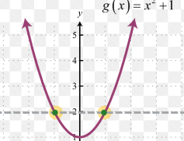 | (b)  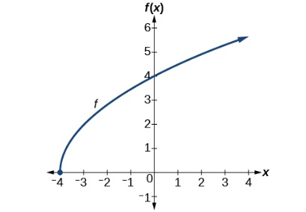
5. Identify which of the following diagram represents function and why? Determine what kind of correspondence each is.
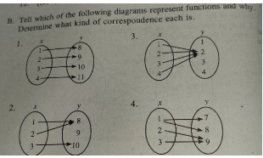
6. On the same axis draw the graph of inverse function of each of the following [2]
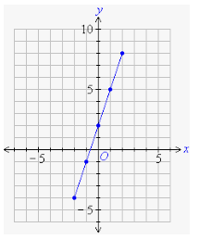 | 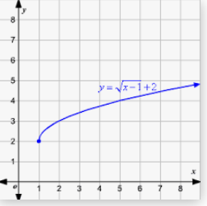
Q7 Draw the graph of the following functions
- $y=-2x+6$
- $y=\sqrt{x}$
- $y=1-\sqrt{3-x}$
- $y=(x-1)(x+2)$
- $y=x^{3}+1$
- $y=x(x-1)(x+2)$
- $y= (x-1)(x+2)(3-x)$
- $y=3×({2)}^{-x}+1$

